SECTION-3 - (JavaScript assignments) Steps to follow:

1. Create a new branch ‘js-assignments’.
2. Switch to ‘js-assignments’ branch.
3. Copy all JavaScript assignments inside ‘Assignments’ folder.
4. Commit JavaScript assignments into ‘js-assignments’ branch.

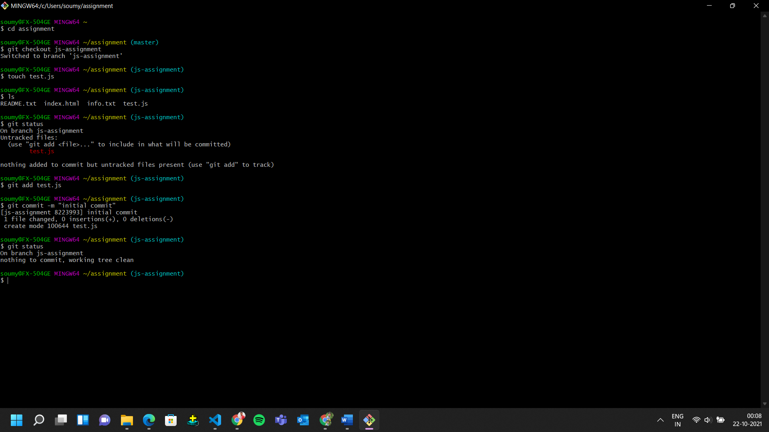

1. Make minor changes into README.txt file on line 1 belonging to ‘js-assignments’ branch.

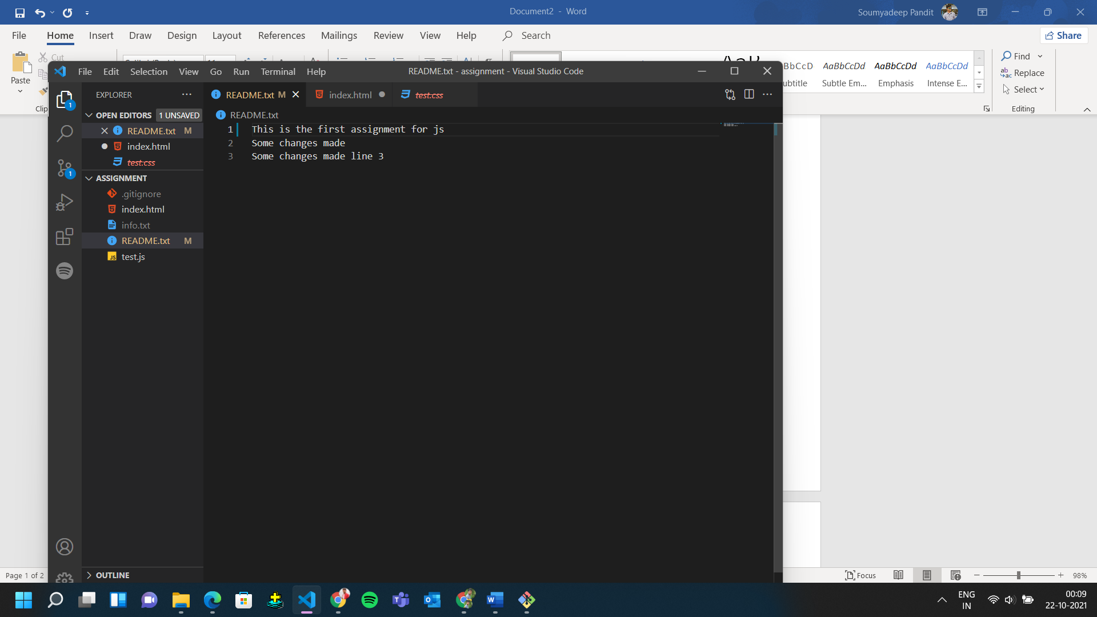

1. Commit those changed files.
2. Switch to master branch.

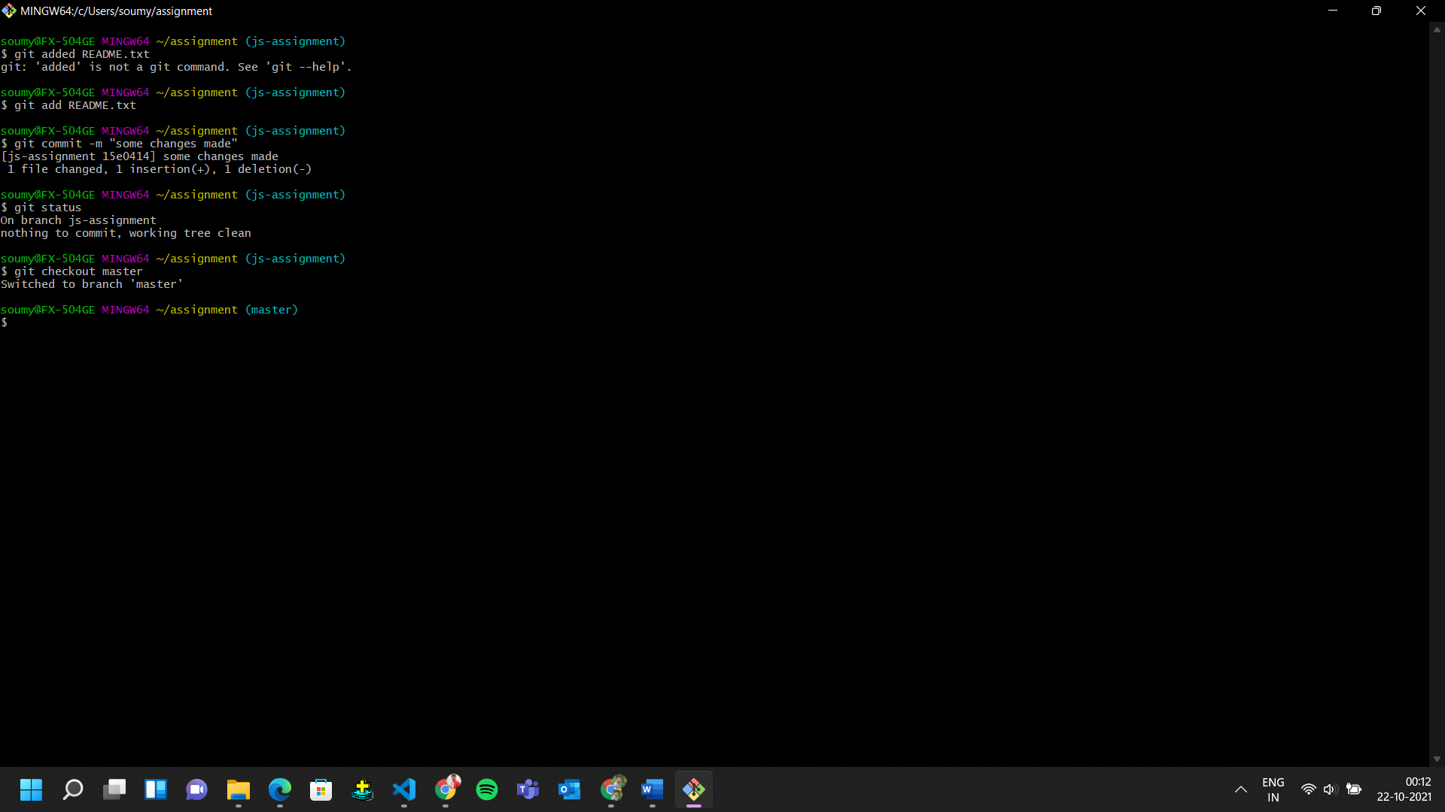

1. Make minor changes into README.txt file on line 1 & commit those changes into master.

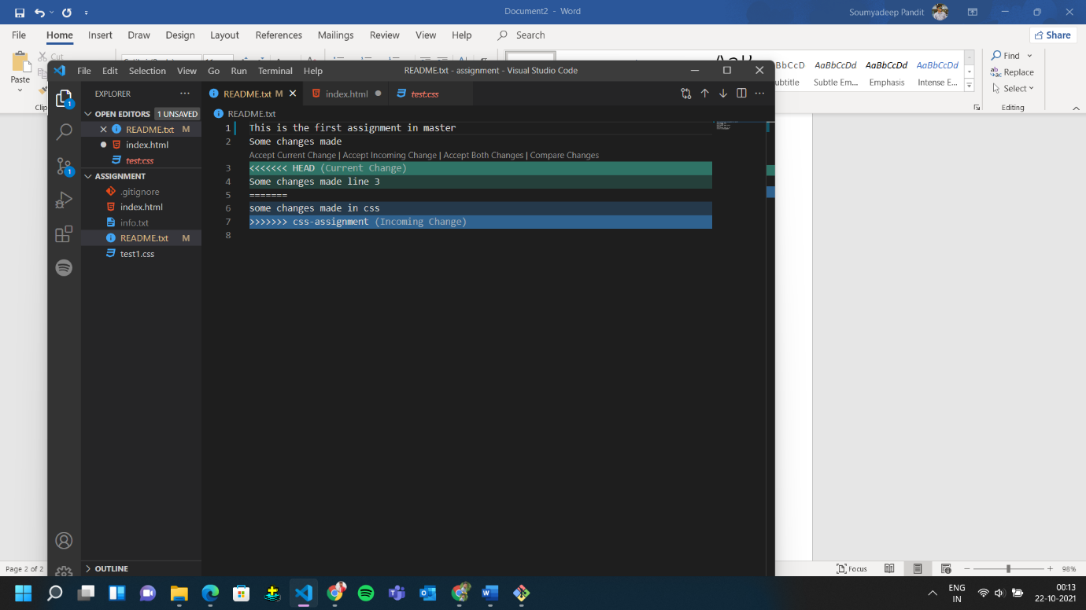

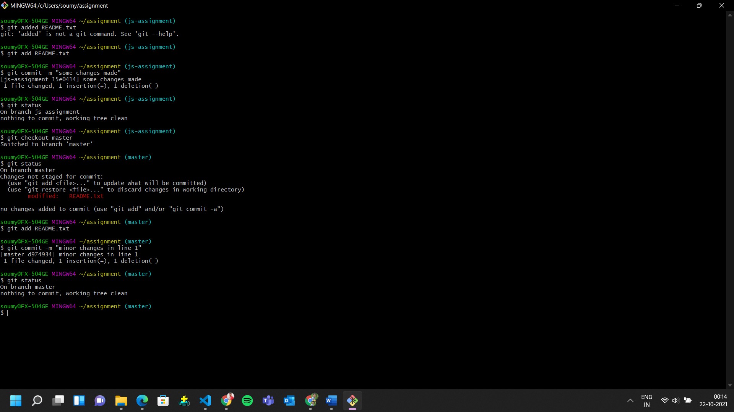

1. Again switch to ‘js-assignments’ branch.

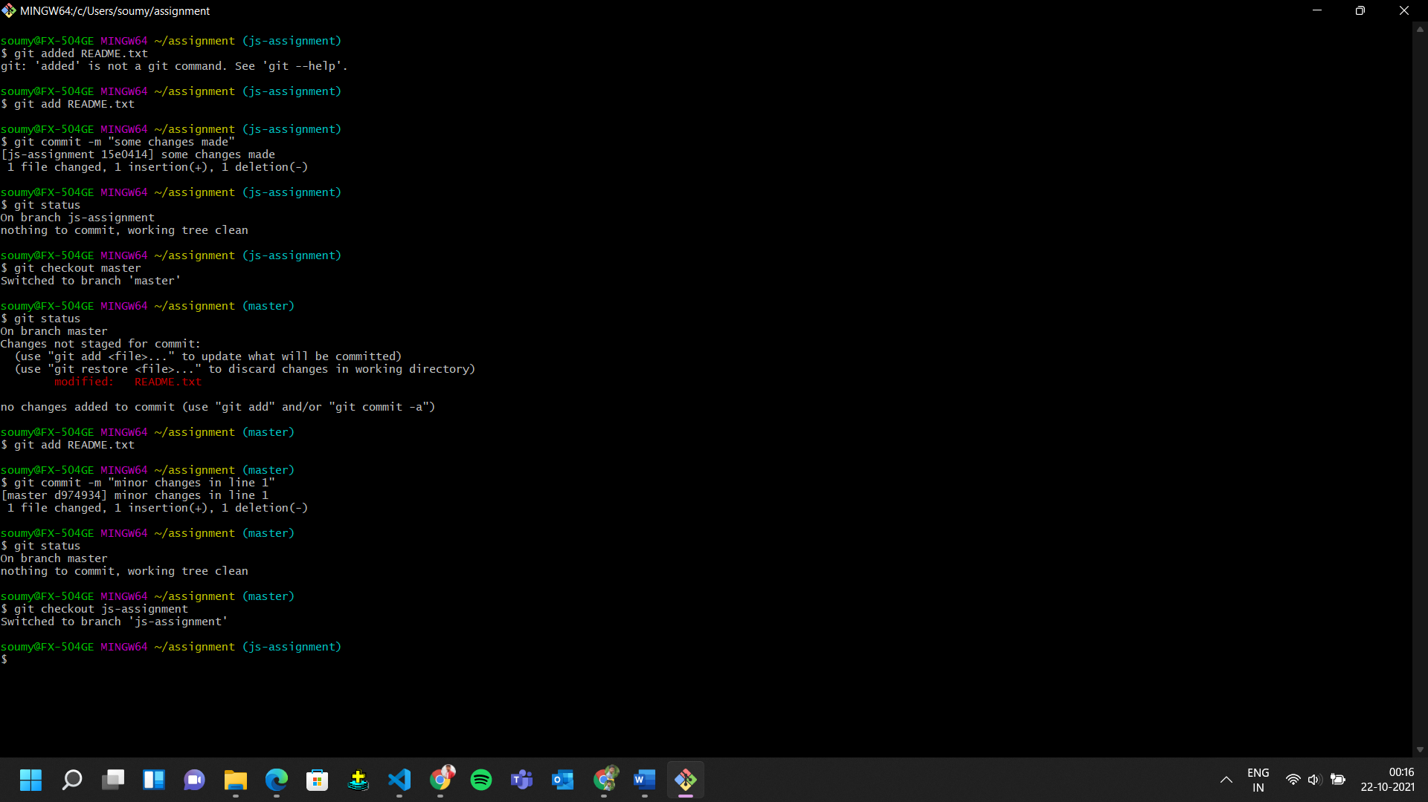

1. Make minor changes into few files belonging to ‘js-assignments’ branch.
2. Commit those changes.

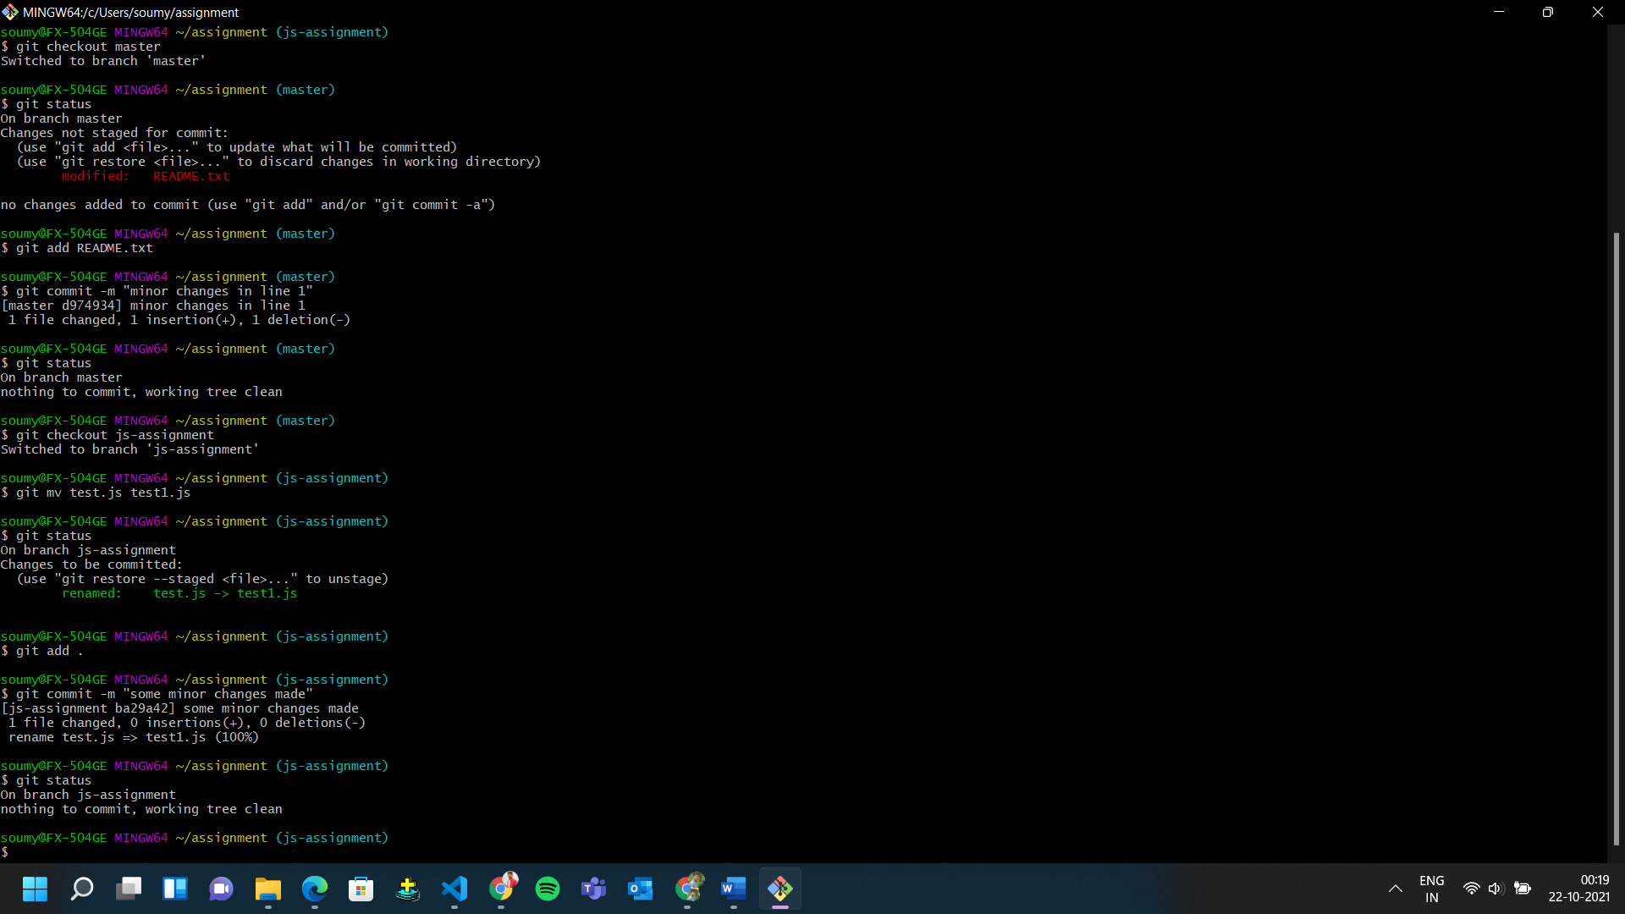

1. Switch to master.

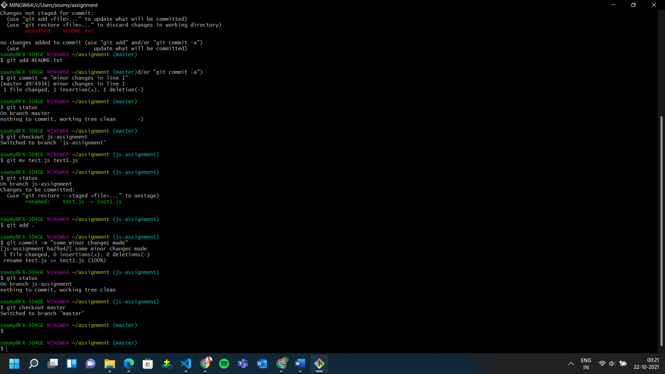

1. Merge ‘js-assignments’ branch into master. Confirm all JavaScript assignments are shown in master.
2. 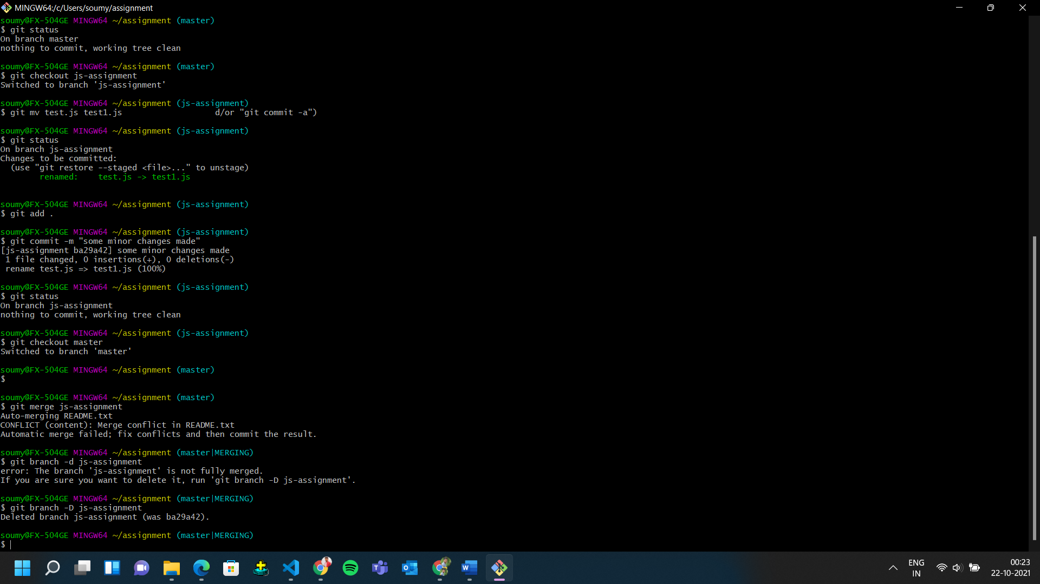Finally delete the ‘js-assignments’ branch.